NHS 111 online ITK Testing Prerequisites
Version 1.1

Contents
Document purpose 3
Testing prerequisites 3
Activation and/or amendments to profiles during the test session 4
Testing checklist 6

Document purpose
The purpose of this document is to set out prerequisites for testing call-back services for NHS 111 online.
For general information on DoS profiling for 111 online please visit the Tools section of our microsite.

Testing prerequisites
There are several prerequisites to testing, and these vary depending on the services in question. This section outlines these prerequisites in simple terms, providing a ‘readiness checklist’ that can be referred to before and during testing as needed.

Submit DoS IDs in a Service Change Template and book testing
DoS IDs to be tested must be submitted to the 111 online implementation team before a testing date can be booked. The Service Change Template provides the implementation team with an idea of how much time to schedule for testing sessions, as well as all the information they need to prepare for and complete testing. The implementation team requires a minimum of 5 working days’ notice from receipt of this template and booking of testing to submit the IDs and get them added to the test ITK approved list. Due to the back-office processes involved, testing cannot occur without sufficient notice.
The Service Change Template provides space to list the details of each DoS service ID (including the ID number and the postcode). Against each service ID row is a column for every DX code relevant to 111 online. These should be marked with an ‘X’ to indicate where testing is required.
See below for a partial example:
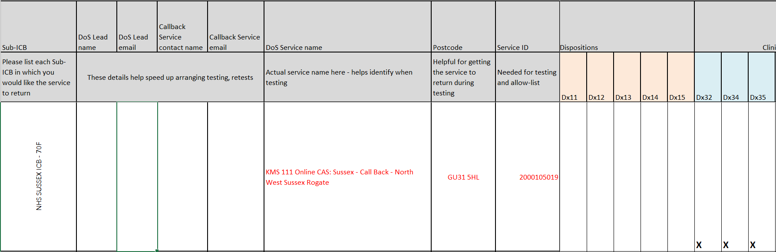
Figure 1 - Example Service Change template entry

Finalise receiving service endpoint configuration
Any service providers who will receive ITKs from 111 online must configure their systems to:
- recognise the DoS service ID;
- recognise and accept the relevant DX codes;
- place incoming messages in the correct queues for management with the correct priority/urgency.
Configuration of DoS profile endpoints MUST be fully completed prior to the testing date.
The following broad questions should have been considered, answered and configured as appropriate before testing is scheduled (detail will vary according to receiving system):
- Which queue will receive referrals?
- Do the DXs need to be added to a system-supplier approved-list to avoid them being rejected upon receipt?
- If relevant, how should these referrals be tagged in the receiving system?
- Who will manage these referrals?
- Are there any upcoming service changes that will require additional configuration after initial implementation?

Activation and/or amendments to profiles during the test session

Add temporary SG/SD codes for testing
The disposition tab on the Service Change template contains a list of SG/SD/DX combinations that are used for the pre-set testing scenarios.
Temporary SG/SD codes can be added to new profiles prior to testing to expedite the testing process, but for existing profiles it is acceptable to add these at the point of testing.

Newly created profiles
Newly created profiles are DoS IDs that are only on the test approved-list at the time of testing. These profiles are not at risk of returning for live users because DoS IDs are only added to the live approved-list once testing has been successfully completed; however, in some cases they can interfere with live returns from DoS and for that reason the following precautions are advised:
- We recommend that new profiles are not made active until the testing session takes place.
- Set patient age range to 119-129. 111 online ITK tests use 119 as the age of the patient. This eliminates the likelihood of the profile interfering with returns for live users during the testing period.

Existing profiles
Existing profiles are DoS IDs that are already on the live approved-list following previous testing.
It is best practice, wherever possible, to create new service IDs where an endpoint/provider change is taking place. This avoids having to test and then re-test when changes are made and reverted prior to go-live. New profiles can then be activated at the point of go-live and old ones closed/retired without risk of errors being introduced with endpoints being copied/pasted/reverted.
Where the intention is to test additional DXs, great care must be taken not to open a service to the live site when the receiving service is not expecting/handling calls.
For this reason, when testing existing (live) profiles, the following precautions are suggested at the point of the testing session:
- Set patient age range to 119-129 before making any other amendments during the testing session. 111 online ITK tests use 119 as the age of the patient. This eliminates the likelihood of the profile returning for live users during the testing period. Age should be set back as soon as testing has completed, as well as removing additional Dx’s or new endpoints unless approval to go live immediately has been received.
- For live services that are profiled for opening times in the out of hours period, the profile will need to be open at the time of test using specified opening times.

Testing checklist
It is important to ensure all of these can be answered in the affirmative before testing is scheduled:
Prerequisite | Responsibility | Met (yes/no)
Have DoS profiles been created for any new receiving services? | DoS Lead
Have DoS profile IDs been identified for existing profiles requiring amendment | DoS Lead
Have any and all receiving system endpoints been configured to recognise relevant DoS profile IDs? (This includes configuration of EDDI services) | Provider
Have any and all receiving system endpoints been configured to recognise relevant dispositions to place them in the correct queue? | Provider
Have all service IDs (new and existing) been collected and submitted to NHS Digital in the DoS ID Service Change template? | DoS Lead / NHS Digital
Have service IDs been added to TEST approved list | NHS Digital
Have all dispositions been profiled with the required SG/SD (temporarily if necessary) for NHS Digital ITK testing? NOTE: For existing live profiles, this must not be done until the testing session. | DoS Lead

